Learning Outcome 02 and 03

Outline the characteristics and values needed for the formation of healthy relationships.

Assessment Criteria

ISR | LEVEL 3 - Assessment criteria | K&U | A&A | S&E
3.1 | Describe the meaning of values through examples | x
3.2 | Contrast the nature of a healthy relationship with that of an unhealthier one |  | x
3.3 | Reflect on own values and life goals in relation to own relationship with others |  |  | x



Values Assessment Worksheet
“A value is defined as a principle, standard, or quality considered inherently worthwhile or desirable. Individuals, groups, and whole societies hold values. Values are what motivate and fulfill you. They imbue your work and your life with meaning. …In essence, a value is what is important to you.”
Julie Jansen, I Don’t Know What I Want, But I Know It’s Not This
“Values are a matter of what guides you through every day, every task, every encounter with another human being.” - Richard N. Bolles, What Color is Your Parachute?
Your “purpose” in life has a lot to do with what kind of impact you want to make in the world and the way you want to live. This is clarified and defined by your values.

Recognise the meaning of values.

Values Clarification Activities
- Recall times when you have been so absorbed in what you were doing that you hardly noticed the time passing by. What were you doing? What were you involved in? Describe the project?

__________________________________________________________________________________

__________________________________________________________________________________

- Think about the things that you find most Meaningful. What do you think of? Include 2 ideals / principles, 2 feelings, and 2 activities.
(Please Turn Over – PTO)
2 Ideals / Principles

__________________________________________________________________________________

2 Feelings

__________________________________________________________________________________

2 Activities

__________________________________________________________________________________

- What values are most important to you? List at least 5 values in your life right now.
- ___________________________________________________________________________

- ___________________________________________________________________________

- ___________________________________________________________________________

- ___________________________________________________________________________

- ___________________________________________________________________________

- Circle (check) all of the values that are most important to you from the examples below and/or add your own.

Achievement/accomplishment
Advancement
Appreciation
Autonomy
Balance
Beauty
Belonging to a group
Bravery
Building something
Career
Challenge
Chastity
Compassion
Competition
Community
Cooperation
Creativity
Creating something new
Creating beauty
Creating change (e.g. social change)
Creating information
Culture
Curiosity
Customs
Decision-making
Dedicate oneself to a mission or person
Education
Enthusiasm
Entrepreneurship

Equality
Excellence
Excitement/risk
Fairness
Fame
Family
Forgiveness
Free Time
Freedom
Financial security
Friendships
Fun
Hard work
Happiness
Harmony
Health
Helping others/serving people
Heritage
Honesty
Hope
Humility
Identity
Inclusion
Influencing people
Improving or perfecting something
Independence
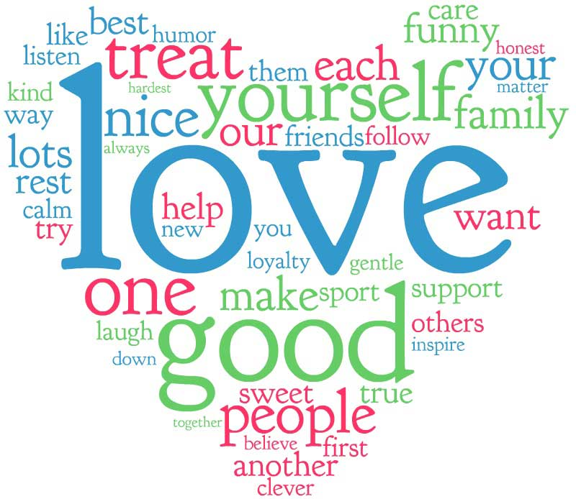
Integrity
Inspiration
Job
Kindness
Leadership
Learning
Leisure
Liberty
Life
Listening
Love
Mastering a technique/field
Mercy
Open-mindedness
Optimism
Peace
Personal development
Persistence
Physical activity
Purity
Purpose
Receiving recognition/impressing people
Repairing or fixing something
Respect
Religion
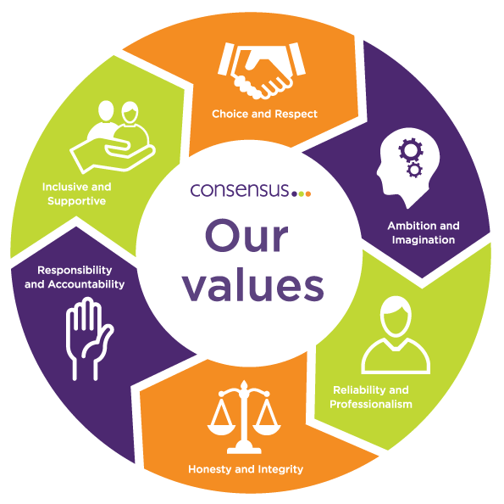
Risk-taking
Safety
Scope
Security
Self-expression
Sharing
Spirituality
Stability
Status
Suffering
Teamwork
Tenacity
Truth
Visioning
Voluntary work
Wealth
Wisdom
Other:_________________
Other:_________________
Other:_________________
Other:_________________

- Now, choose the ten most important to you and then prioritize them.

- ________________________

- ________________________

- ________________________

- ________________________

- ________________________

- ________________________

- ________________________

- ________________________

- ________________________

- ________________________

Identify common personal characteristics of persons who share the same values.

- Mention 5 common personal characteristics of persons who like you have a passion for the same choice of career and other similar interests.

- ___________________________________________________________________________

- ___________________________________________________________________________

- ___________________________________________________________________________

- ___________________________________________________________________________

- ___________________________________________________________________________
Relate own strengths, talents and capabilities with choice of prospective career

- When it comes to your choice of possible career, can you describe in your own words what are your strengths, talents and capabilities for your choice?

Your Strengths for your career choice.

__________________________________________________________________________________

__________________________________________________________________________________

Your Talents for your career choice.

__________________________________________________________________________________

__________________________________________________________________________________

Your Capabilities/Skills/Competences for your career choice.

__________________________________________________________________________________

__________________________________________________________________________________

Identify the major qualities that contribute to the development of a strong personal intimate relationship.

- Which are according to your opinion, the 3 major qualities that contribute to the development of a strong personal intimate relationship?

1: ________________________________________________________________________________

2: ________________________________________________________________________________

3: ________________________________________________________________________________

Rank in your order of priority, which of the Values (below) show most ‘RESPECT’.
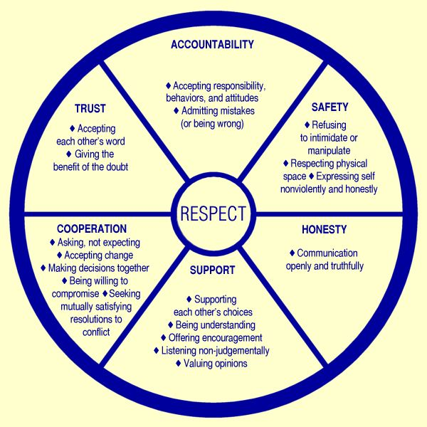
1st:
___________________________

2nd:
___________________________

3rd:
___________________________

4th:
___________________________

5th:
___________________________

6th:
___________________________

C3. Explain personal genuine motives and feelings towards initiating and/or maintaining a personal intimate relationship.

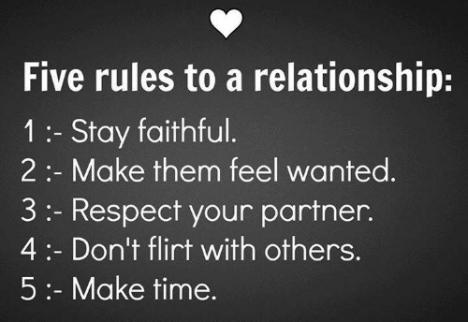
9. How do you feel about these ‘Five rules to a Relationship’? What are your thoughts? Why are these basic rules important? What are the consequences if these 5 basic rules are broken?

9a. How do you feel about these 5 rules?

_____________________________________

_____________________________________

__________________________________________________________________________________

9b. Why are these basic rules important?

__________________________________________________________________________________

__________________________________________________________________________________

Explain personal genuine motives and feelings towards being in a personal intimate relationship.

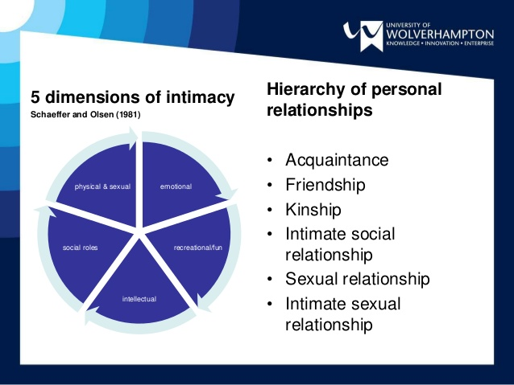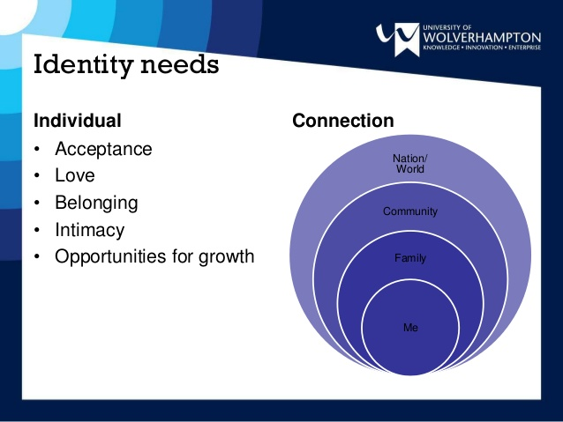

- What do you look for before starting a personal intimate relationship? What are the most important Life qualities you want to achieve through a relationship?

__________________________________________________________________________________

__________________________________________________________________________________

__________________________________________________________________________________

__________________________________________________________________________________

C5. Predict the impact of a set decision upon the status of a relationship.

- What are the consequences if these 5 basic rules are broken?

11a. If you’re not faithful?

__________________________________________________________________________________

11b. If you don’t make your partner feel wanted?

__________________________________________________________________________________

11c. If you don’t respect your partner?

__________________________________________________________________________________

11d. If you flirt with others?

__________________________________________________________________________________

11e. If you do not make time for your partner and each other?

__________________________________________________________________________________

C6. Discuss the implications of acting irresponsibly in varying situations such as intimate engagements, the use of diverse substances and other habitual practices.

Read and observe the warning signs of unhealthy relationships in this picture and answer the questions on the next page.

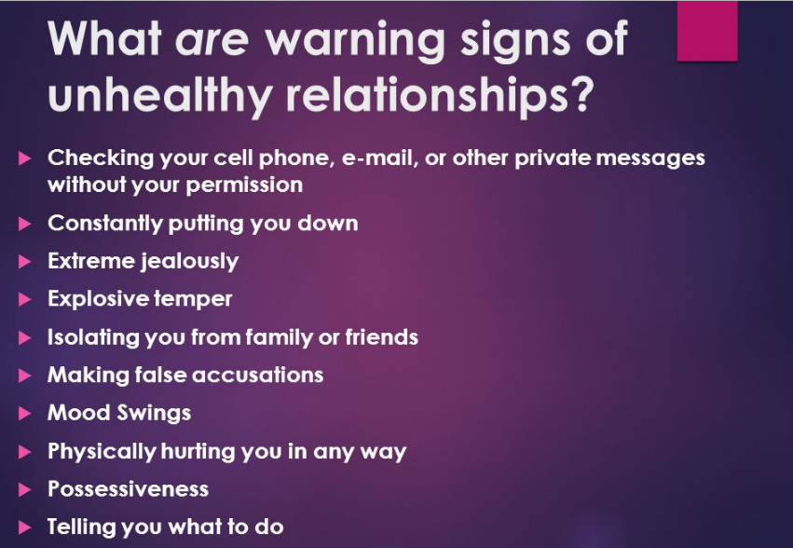

Discuss in your own words, what according to you are those implications/consequences of acting IRRESPONSIBLY on a personal intimate relationship?

__________________________________________________________________________________

__________________________________________________________________________________

What are the implications/consequences of acting IRRESPONSIBLY on the use of diverse substances?

__________________________________________________________________________________

__________________________________________________________________________________

What are the implications/consequences of acting IRRESPONSIBLY on other habitual practices such as over-speeding?

__________________________________________________________________________________

__________________________________________________________________________________

